Decolonizing Human Rights for Human Liberation

North-South Project for People(s)-Centered Human Rights

Director: Ajamu Baraka

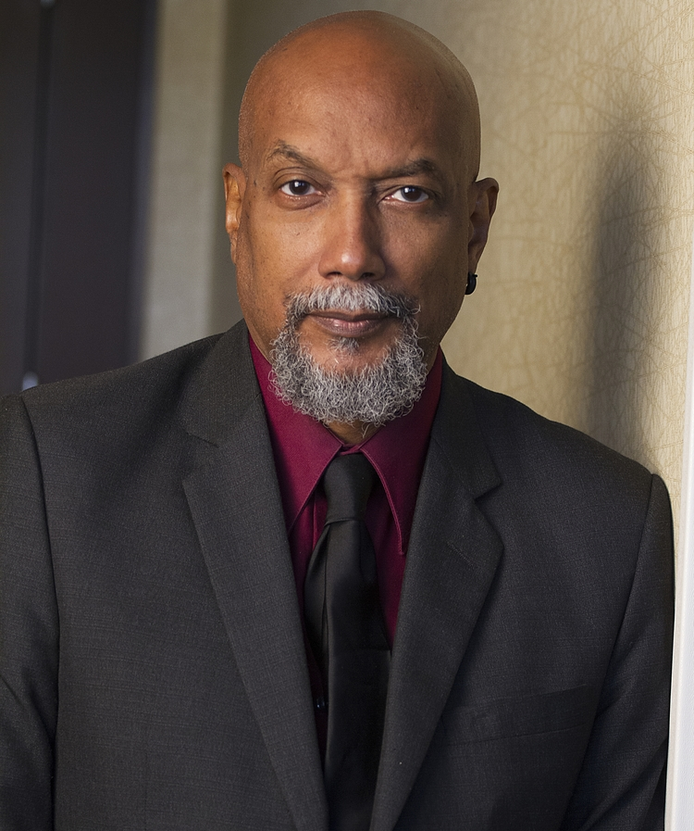

Ajamu Baraka is a geopolitical analyst, organizer, writer, human rights defender, and veteran of the U.S. Black Liberation Movement with over 54 years of work in the U.S. and internationally. Baraka is the founder of the Black Alliance for Peace (BAP) and currently serves as the director of BAP’s North-South Project for People(s)-Centered Human Rights. Recently Baraka co-founded the International Coalition to Stop Genocide in Gaza to support the South African case filed with the International Court of Justice. In 2016 Baraka was a candidate for Vice President of the United States on the Green Party ticket. He currently serves on the Executive Committee of the U.S. Peace Council and the leadership body of the United National Anti-War Coalition (UNAC). He is an editor and contributing columnist for the Black Agenda Report and the recipient of the Serena Shirm award for uncompromised integrity in journalism. In 2019 Baraka was awarded the US Peace Memorial’s Peace Prize.

Mission of North-South Project for People(s)-Centered Human Rights:

The North-South Project for People(s)-Centered Human Rights (the “Project”) will contribute to the building of an alternative human rights frame that is liberated from the liberal, individual, legalistic, and state-centered apparatus that emerged at the conclusion of World War II as a “Western” human rights regime that became, and continues to be, a conservative weapon for enforcing the geopolitical interests of Western imperialism. The Western supported genocide in Gaza and the continued annexation of the Occupied West Bank has sharpened the irreconcilable contradictions of the Western human rights project resulting in the crisis of legitimacy that it is now experiencing. By rejecting the ideological mystification of a neutral and objective human rights framework, the Project, through educational activities, building transnational cooperative structures and supporting popular struggles, will link oppressed communities, classes and “peoples” from the Global North and South that are moving toward developing movements committed to national and global anti-capitalist, de-colonial and anti-imperialist struggles for social justice, ecological sustainability, national liberation and authentic self-determination.

Why the Link between the global North and South?

The United States settler state was established by the violent theft of Indigenous land through conquest and the importation of enslaved Africans who were forced to provide free labor using systematic, unspeakable physical violence such as lynching, rape, race riots, torture and murders by police forces.
These forms of violence constituted the method by which structures of settler colonialism, white supremacy and racial capitalism were established, reproduced and thrived, and are the methods by which the U.S. capitalist state maintains its dominance globally using military interventions to control the labor, land and mineral wealth of the vast majority of the world’s peoples.

Why People(s)-Centered Human Rights
Despite what proponents of human rights proclaim, the human rights idea is not innocent. The notion of human rights emerged as an aspect of classical liberalism at a particular historical moment in Europe informed by the internal class/social struggles and the colonialist expansion of various European powers.
While classical European liberalism professed a fidelity to the “rights of man” and the proclamation that all “men” are equal, it simultaneously provided philosophical justifications for slavery, genocide, settler colonialism, capitalism, patriarchy and imperialism – systems that degrade, dominate, destroy, and systemically oppress human subjects.
The systematic degradation, dehumanization and murder of Palestinians with the full support of the “collective West,” is a graphic example the moral dualism of the white supremacist Western project.
How has liberalism been able to achieve this? Because at the heart of the liberal project are exclusionary criteria for who deserves to have rights, that tragically for millions of people during the last 500 years of European dominance, rest on a stratification of humanity in which Europeans and their civilizational project is at the apex. It is that internal moral contradiction that explains how Thomas Jefferson could speak of fundamental equality while holding slaves and raping Black women; how Winston Churchill could call for self-determination of nations while maintaining a colonial empire; how U.S. authorities can justify kidnapping and assassination even of U.S. citizens and the invasions of States, all in the name of fighting Islamic terrorists; and how war can be employed in the name of “humanitarian intervention” and the “responsibility to protect” but is ignored when Palestinians face a racist genocide.
Therefore, for social justice activists around the world, but particularly in the global South, it was precisely these moral contradictions by both Western and non-Western states that created deep dissatisfaction and mistrust of human rights as an instrument for radical social change. It appears to many of these activists that the orthodox framework is not able to offer any more than bland reforms and a depoliticized politics.
In response to the human rights crisis of relevance, a “people(s)-centered human rights” (PCHRs) concept and approach has been developing from the margins of the U.S. human rights movement over the last few years. Introduced in 2004 by Ajamu Baraka, human rights activist and co-founder of the Black Alliance for Peace, the PCHRS framework is informed by the African American radical human rights tradition and recognizes the contingent and contested nature of human rights framework. The modern expression of PCHRs developed out of the organizing and agitation directed at the newly formed United Nations between 1945 and 1951 and subsequently taken up by figures like Malcolm X and elements of the radical Black anti-colonial, revolutionary movements in the 1960s. This tradition of human rights struggle combined the struggle against white supremacy and anti-colonialism with a commitment to domestic and global systemic transformation. As a political project historically and socially grounded in the needs and realities of oppressed communities and peoples and committed to social justice and the development of the people as autonomous political subjects, it rejects the mystification of the supposedly non-political, universalist perspective and practice of human rights.
There was something quite different with Malcolm’s approach to human rights that distinguished him from mainstream civil rights activists. By grounding himself in the radical human rights approach, Malcolm articulated a position on human rights struggle that did not contain itself to just advocacy. He understood that appealing to the same powers that were responsible for the structures of oppression was a dead end. Those kinds of unwise and potentially reactionary appeals would never result in substantial structural changes. Malcolm understood oppressed peoples must commit themselves to radical political struggle in order to advance a dignified approach to human rights.
“We have to make the world see that the problem that we’re confronted with is a problem for humanity. It’s not a Negro problem; it’s not an American problem. You and I have to make it a world problem, make the world aware that there’ll be no peace on this earth as long as our human rights are being violated in America.”
And if the U.S. and the international community does not address the human rights plight of the African American, Malcolm is clear on the course of action: “If we can’t be recognized and respected as a human being, we have to create a situation where no human being will enjoy life, liberty, and the pursuit of happiness.”
Malcolm’s approach to the realization of human rights was one in which human agency is at the center. If oppressed individuals are not willing to fight for their human rights, Malcolm suggested that “you should be kept in the cotton patch where you’re not a human being.”
If you are not ready to pay the price required to experience full dignity as a person and as members of a self-determinant people, then you will be consigned to the “zone of non-being,” as Fanon refers to that place where the non-European is assigned. Malcolm referred to that zone as a place where one is a sub-human:
“You’re an animal that belongs in the cotton patch like a horse and a cow, or a chicken or a possum, if you’re not ready to pay the price that is necessary to be paid for recognition and respect as a human being.
“And what is that price?
“The price to make others respect your human rights is death. You have to be ready to die… it’s time for you and me now to let the world know how peaceful we are, how well-meaning we are, how law-abiding we wish to be. But at the same time, we have to let the same world know we’ll blow their world sky-high if we’re not respected and recognized and treated the same as other human beings are treated.”
In the contemporary period, PCHRs advocates continue that approach but with an even more explicit focus on naming the main enemy of human rights – the Pan European White Supremacist, Colonial/capitalist patriarchy.
What is the definition of People(s)-Centered Human Rights?
People(s)-Centered Human Rights (PCHR) are those non-oppressive rights that reflect the highest commitment to universal human dignity and social justice that individuals and collectives define and secure for themselves and Collective Humanity through social struggle.
This definition is a description of a process and an ethical framework as opposed to a pre-figured list of items defined as representing human rights. This is one of the key differences between the liberal framework and PCHRs. The PCHRs approach asserts that human rights must be created from the bottom-up.
PCHRs approach to human rights activism does not limit itself to a national legal regime or to the normative standards reflected in international human rights treaties, covenants or declarations. While this approach recognizes the importance of these texts and the legal and ethical principles implied in them, the ultimate meaning of the language in the texts, the scope of rights that will be recognized, and the modalities for rights implementation, are an evolving process whose final determination is dependent on popular political struggles and societal dispensations of power. De-linked from the bias and partial ontology of classical liberalism—and grounded in the racist, sexist and classist pretentions of natural law and presumptuousness of its universality—the content and teleology of human rights becomes an area of contention itself.
This is not to say that the people-centered approach lacks a “foundation” or source of legitimacy—nor is it arguing for moral relativity. The approach simply recognizes a different foundation, source of legitimacy and moral authority – that of the people’s positive struggle for social justice. Therefore, the “people” in struggle, with an understanding that the construction of the “people” is a political process informed by specific national realities, the PCHRs approach eschews the legalistic and morally vacuous debates around “collective rights” and the “justiciability” of economic, social and cultural rights, while real live “collectives” (peoples) are starving; losing lands to transnational corporations, being denied the right to speak their languages, or having their leaders killed. The “universal” norms that a people-centered process would reflect would be grounded in and guided by the needs and aspirations of the people.
This is the Black Radical Tradition’s approach to human rights. It is an approach that views human rights as an arena of struggle that, when grounded and informed by the needs and aspirations of the oppressed, becomes part of a unified comprehensive strategy for de-colonization and radical social change.
The PCHR framework provides an alternative and theoretical and practical break with the race and class-bound liberalism and mechanistic state-centered legalism that informs mainstream human rights.
The people-centered framework proceeds from the assumption that the genesis of the assaults on human dignity that are at the core of human rights violations is located in the relationships of oppression. The PCHR framework does not pretend to be non-political. It is a political project in the service of the oppressed. It names the main enemies of human dignity and rights: the Pan European white supremacist, colonial/capitalist patriarchy and all forms of human oppression that flow this material reality.
Therefore, the realization of authentic freedom and human dignity can only come about as a result of the radical alteration of the structures and relationships that determine and often deny human dignity. In other words, it is only through social revolution that human rights can be realized.
The demands for clean water; safe and accessible food; free quality education; healthcare and healthiness for all; housing; public transportation; wages and a socially productive job that allow for a dignified life; ending of mass incarceration; universal free child care; opposition to war and the control and eventual elimination of the police; self-determination; and respect for democracy in all aspects of life are some of the people-centered human rights that can only be realized through a bottom-up mass movement for building popular power.
By shifting the center of human rights struggle away from advocacy to struggle, Malcolm laid the foundation for a more relevant form of human rights struggle for people still caught in the tentacles of Euro-American colonial dominance. The PCHR approach that creates human rights from the bottom-up views human rights as an arena of struggle. Human rights does not emanate from legalistic texts negotiated by states—it comes from the aspirations of the people. Unlike the liberal conception of human rights that elevates some mystical notions of natural law (which is really bourgeois law) as the foundation of rights, the “people” in formation are the ethical foundation and source of PCHRs.

Resources:

PEOPLE-CENTERED HUMAN RIGHTS
Book Chapters and Articles

Albisa, C. (2009/2007). “First Person Perspectives on the Growth of the Movement: Ajamu Baraka, Larry Cox, Loretta Ross, and Lisa Crooms.” In C. Albisa, M.F Davis, & C. Soohoo, edition, Bringing Human Rights Home: A History of Human Rights in the United States [3 volumes]. Westport, CT: Praeger. Pp. 49-70.

Baraka, A. (Feb. 21, 2024). “People Centered Human Rights and the Black Radical Tradition.”https://www.blackagendareport.com/people-centered-human-rights-and-black-radical-tradition-0
Baraka, A. (2023). “Praxis from the Centre Back to the Margins: Amilcar Cabral’s Method as a Guide for Reconstructing the Radical Black Political Subject.” In F. Manji & B. Fletcher’s, Second revised edition, In Claim No Easy Victories: The Legacy of Amilcar Cabral. Brooklyn, NY: Common Notions Press. Pp. 375-382. https://darajapress.com/publication/claim-no-easy-victories-the-legacy-of-amilcar-cabral-new-expanded-edtion
Baraka, A. (May 18, 2021). “From Palestine to Colombia: The End of the White World Colonial-Capitalist Project?” https://towardfreedom.org/americas-2/from-palestine-to-colombia-the-end-of-the-white-world-colonial-capitalist-project/

Baraka, A. (2019). Forward. “Countering the Violence of Imposed Forgetting.” In R. Sirvent & D. Haiphong edition, American Exceptionalism and American Innocence: A People's History of Fake News―From the Revolutionary War to the War on Terror. NY: Skyhorse Publishing. https://www.skyhorsepublishing.com/9781510742369/american-exceptionalism-and-american-innocence/

Baraka, A. (2018). “Forward.” In F. Jerome’s edition, The Einstein File: The FBI’s Secret War Against the World’s Most Famous Scientist. Montreal, Quebec: Baraka Books. https://www.amazon.com/s?k=the+einstein+file&i=stripbooks&crid=23C4BWWPSAJCK&sprefix=the+einstein+file%2Cstripbooks%2C1143&ref=nb_sb_noss [This book has several foreign language editions, which include Farsi/Persian, German, French, and Spanish]

Baraka, A. (Dec. 10, 2018). “The Universal Declaration of Human Rights at 70: Time to De-Colonize Human Rights!” Independent Political Report, https://independentpoliticalreport.com/2018/12/the-universal-declaration-of-human-rights-at-70-time-to-de-colonize-human-rights/

Baraka, A. (2017). Afterword: “Home Isn’t Always Where the Hatred Is: There is Hope In Mississippi.” In K. Akuno & M. Meyer’s edition, Jackson Rising Redux: Lessons on Building the Future in the Present. Oakland, CA: PM Press. https://pmpress.org/index.php?l=product_detail&p=1188 [This book has a foreign language edition. It is published with a Spanish publication out of Barcelona, Spain].

Baraka, A. (April 1, 2015). “Invading Yemen: Criminality in Support of Hegemony.” Guardian (Sydney), ISSN (PRINT): 1325-295X, Issue No. 1679. https://search.informit.org/doi/abs/10.3316/informit.142937652937383
Baraka, A. (April. 29, 2015). “Baltimore and the Human Right to Resistance.” Counterpunch, https://www.counterpunch.org/2015/04/29/baltimore-and-the-human-right-to-resistance-2/

Baraka, A. (2014). “Socialism is the Highest Expression of Human Rights.” F. Goldin, D. Smith, & M. Smith’s edition, Imagine Living in a Socialist U.S.A. Pp. 71-76. NY: HarperCollins. https://www.barnesandnoble.com/w/imagine-frances-goldin/1115888725?ean=9780062305589

Baraka, A. (2014). “For a National Alliance for Racial Justice and Human Rights.” In K. A. Gray, J. St. Clair, J. Wypijewski’s edition, Killing Trayvons: An Anthology of American Violence. Petrolia, CA: CounterPunch Books. Pp. 121-124. https://www.barnesandnoble.com/w/killing-trayvons-jeffrey-st-clair/1121606216?ean=9780692213995
Baraka, A. (2013). “Trayvon Martin and the Need for an Independent Human Rights Movement.” Proudflesh: New African Journal of Culture, Politics and Consciousness, Issue No. 7. ISSN: 1543-0855. https://www.africaknowledgeproject.org/index.php/proudflesh/article/view/1747/0
Baraka, A. (June 20. 2013). “The Empire’s New Clothes: Humanitarian Intervention Stripped Bare,” https://fpif.org/the_empires_new_clothes_humanitarian_intervention_stripped_bare/
Baraka, A. (Sept 5. 2013), “Humanitarian Intervention: The Gift that Keeps on Giving to U.S. Imperialism,” https://fpif.org/humanitarian-intervention-gift-keeps-giving-u-s-imperialism/
Baraka, A. (Dec 11. 2013). “The Need for an Ethical and Political De-Colonization of Human Rights,” https://www.counterpunch.org/2013/12/11/the-need-for-an-ethical-and-political-de-colonization-of-human-rights/
Baraka, A. (Dec. 10, 2013). “Human Rights Project Determined by the Needs of the Powerful.” https://fpif.org/human-rights-project-determined-needs-powerful/
Baraka, A. (Sept. 27, 2012). “Human Rights and Humanitarian Imperialism in Syria: A View from an African American Human Rights Defenders.” Pambazuka Issue 599. https://www.wrongkindofgreen.org/2012.09/30/human-rights-and-humanitarian-imperialism-in-syria/
Lusane, C. (2004). “Changing (Dis)Course: Mainstreaming Human Rights in the Struggle Against U.S. Racism,” The Black Scholar, Vol. 34, No. 3, BLACK POLITICS 2004 (FALL 2004), pp. 21-33 (13 pages) Published By: Taylor & Francis, Ltd.

